Problem Statement:

● Explain and perform Importing table contents from Mysql to Hive using Sqoop.

Here’s what each individual Sqoop command option means:

* connect – Provides jdbc string
* username – Database username
* -P – Will ask for the password in console. Alternatively you can use –password but this is not a good practice as its visible in your job execution logs and asking for trouble. One way to deal with this is store database passwords in a file in HDFS and provide at runtime.
* table – Tells the computer which table you want to import from MySQL
* split-by – Specifies your splitting column. I am specifying id here.
* target-dir – HDFS destination directory.
* fields-terminated-by – I have specified comma (as by default it will import data into HDFS with comma-separated values)
* hive-import – Import table into Hive (Uses Hive’s default delimiters if none are set.)
* create-hive-table – Determines if set job will fail if a Hive table already exists.
* hive-table – Specifies <db_name>.<table_name>.

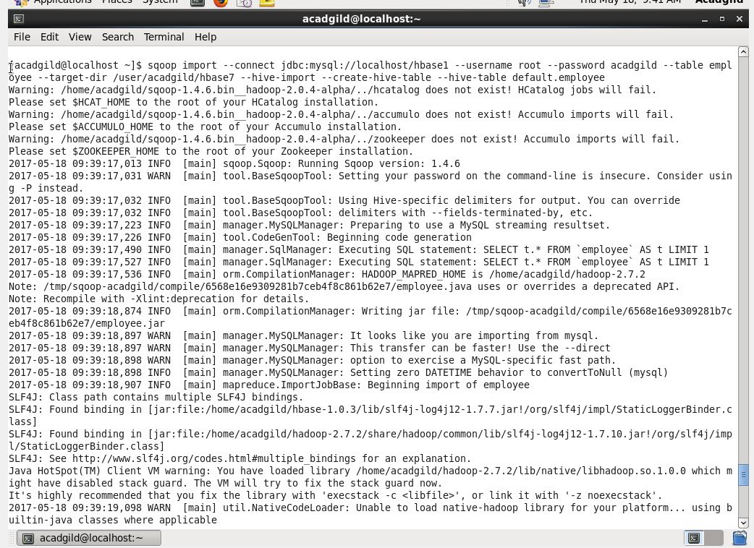

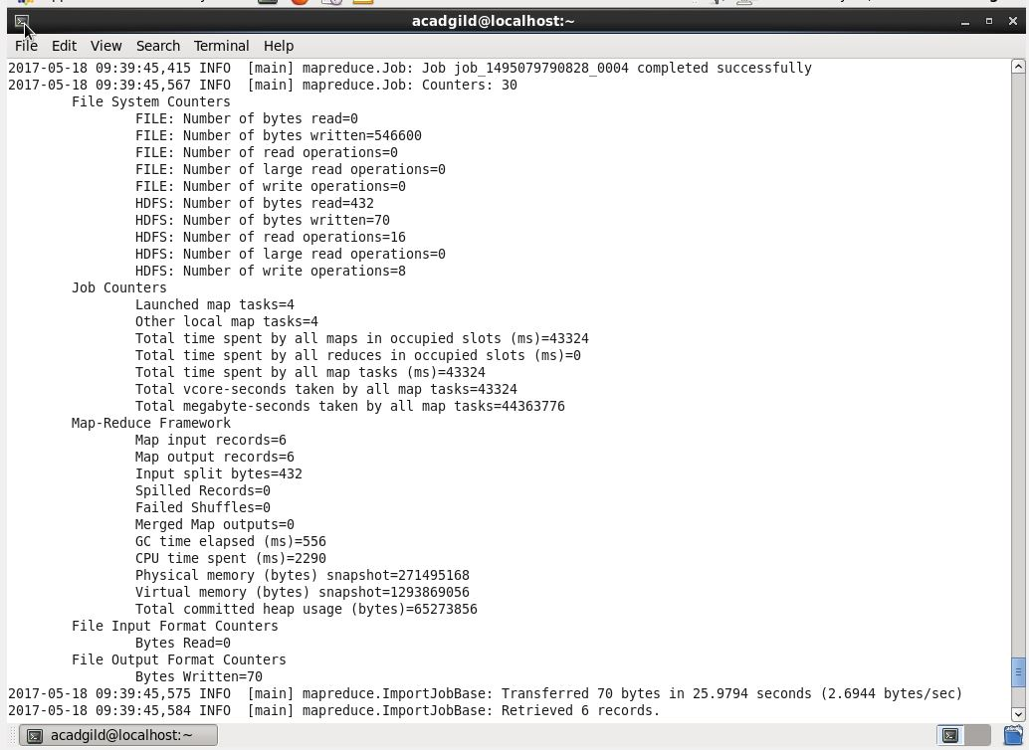

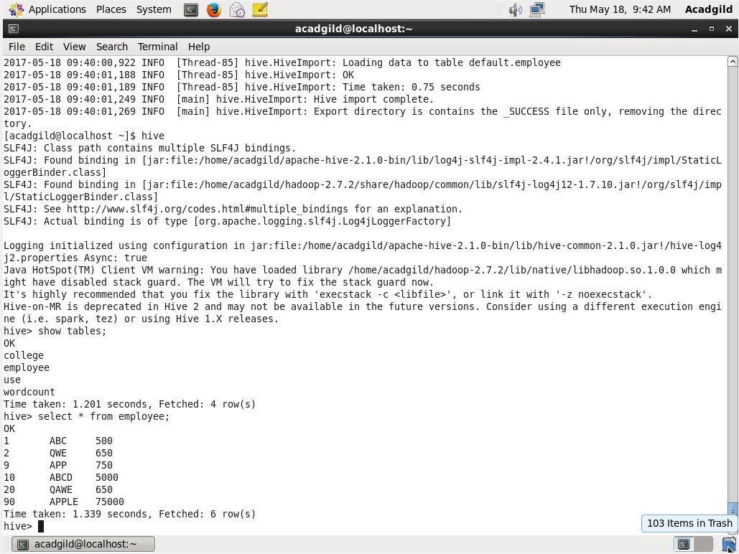

● Explain and perform Importing table contents from Mysql to HBase using Sqoop.

